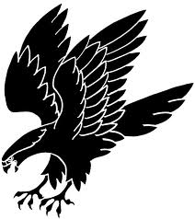
Ft. Clarke Girls Soccer: Parent Code of Conduct

- I will remember that youth sports are played for fun!
- I will be a role model for my team demonstrating how to treat other players, parents, officials and coaches with respect at all times.
- I will demonstrate good sportsmanship regardless of the score by acting in a positive manner towards all players, officials, parents and coaches.
- I will show respect to all referees, officials or umpires and never act in a manner that would be disrespectful toward them.
- I will be an encouragement to all players on all teams regardless of the score.
- I will place my child’s emotional and physical well being ahead of my own personal desire to win.
- I will remember that the game is played for the youth and not for the adults.
- I will encourage my child to shake hands with the other team at the conclusion of all games.
- I will encourage my child to shake hands with the officials at the conclusion of all games.

Adopted from National Youth Sports

Parent Signature: __________________________________

Parent Signature: __________________________________

